OFFICE INFORMATION SUNDAYS
Monday – Friday, Discipleship Classes: 9AM
8:30 - Noon Worship: 10AM
Phone: 618-932-2866 ALL Youth: 5PM-7PM
Fax/Voice: 618-937-2118
Website: www.wftrinity.com
E-mail: trinityumc@wftrinity.com

304 N. SUNNY SLOPE ST., WEST FRANKFORT, IL 62896

June Conference/Camps
While May was filled with special Sundays, June begins our conference/camping season. Please pray for our Illinois Great Rivers Annual Conference which will be held in Peoria June 6-8. Every church in our conference will be represented by clergy and one or more lay delegates. We will make decisions which impact all of the churches in the Conference. We will also celebrate and worship together. This is a critical time for the United Methodist Church. We need your prayers.
Trinity will send young campers to three different summer camps at Beulah in Eldorado in June (and one in July). Once again, prayer is requested. These camp experiences are often cherished forever and can be life-changing. Pray for the leaders of the camps, our own Trinity sponsors/helpers, and the services/ministries during the camp. Most of all, please pray that the hearts and minds of our children and youth will be open to the unfailing and unfathomable love of God through Christ Jesus.
If you have a child/teen that is interested in attending, please see Brian or Honey Bejmovicz as soon as possible. Thanks to your church participation, your prayers, and your financial support, we will once again be able to impact many young lives for Christ.

Living the GodLife,

Pastor Joey

FOR THE MONTH…
- GREETERS: Tim & Brenda Weaver, Marilyn Williams
- USHERS: Tim Ondo, Brad Campbell, Kyle Foder, Todd Culp,
Jack Calvert, Gavyn Woolard
- DOORPERSON: Marsha Schultz

June 2
- NURSERY: Sara Jacobs & Aleah Russell
- JAM: Jackie Wilson, Matt Jacobs, Andrew Jacobs, Bella Wilson,
Adam Milligan
June 9
- NURSERY: Jan Farkas & Emma Chick
- JAM: Honey Bejmovicz, Johnny Mize, Jesse Helfrich, Emma Chick,
Zachary Helfrich
June 16
- NURSERY: Amy Bates & Quincy Bates
- JAM: Martha Swift, Samantha Mize, Paige Mize, Morgan Reiger,
Aleah Russell
June 23
- NURSERY: Jane Murphy & Hannah Adkins
- JAM: Jackie Wilson, Matt Jacobs, Andrew Jacobs, Bella Wilson,
Adam Milligan
June 30
- NURSERY: Kim Fleck & Brooklyn Dodd
- JAM: Honey Bejmovicz, Johnny Mize, Jesse Helfrich, Emma Chick,
Zachary Helfrich

VACATION BIBLE SCHOOL INFORMATIONAL MEETING…for ANYONE who is interested in, or already planning on, helping with VBS (July 14-18, 5PM-8PM) will be on Wednesday, June 5, 6PM in the JAM room.
ANNUAL CONFERENCE…will be Thursday, June 6-Saturday, June 8. Be in Prayer for the Conference.
FATHER’S DAY…is June 16!!
SUSANNA CIRCLE…Tuesday, June 18, 6PM in the JAM room. All ladies of the church are encouraged to attend!
BAKE SALE FUNDRAISER…will be Sunday, June 30. Proceeds from this bake sale will given to the Piper Castellano family to help cover continuing expenses incurred with chemo treatments in St. Louis.
STAFF MEETING…every Monday, 8:30AM in the JOY Room.

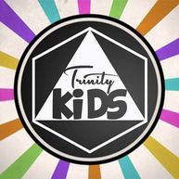

KIDS SUMMER MOVIE CAMP...Wednesday, June 12 (Wonder Park). Leave Trinity at 9AM. Cost is $4 per child, and that includes, ticket, popcorn, drink & candy. Come join us!! Kindergarten through 6th graders.
BEULAH-THE BEGINNING CAMP…June 28-29. Grades 2nd-4th.

MAY FAITHFULNESS

DATE ATTENDANCE OFFERING

5 Worship – 139 $7,065.
JAM - 15
Discipleship Classes – 40
12 Worship – 173 $3,645.
JAM – 23
Discipleship Classes - 48
19 Worship – 174 $4,557.
JAM – 18
Discipleship Classes – 53
26 Worship – 131 $5,428.
JAM – 18
Discipleship Classes – 41

2019 Budget Goal: $353,585.

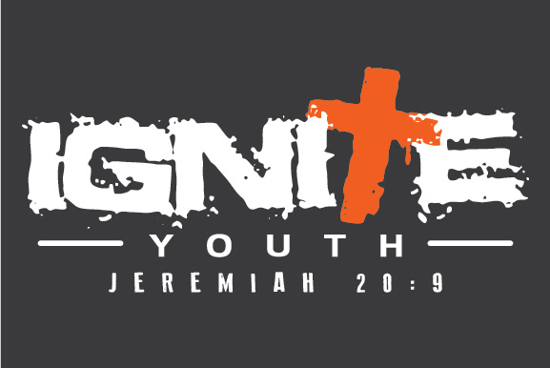

SUNDAY NIGHT LIVE…EVERY Sunday @ 5PM. Worship, Bible & Fun! NO YOUTH June 16. This is the week of BYI.
BEULAH CAMP CLEANING DAY…for all Jr. & Sr. High campers is Saturday, June 1. Meet at church at 10AM. Bring $$ for lunch.
POOL PARTY/OUTDOOR MOVIE…Saturday, June 1, 6PM, at the home of Chris Russell, 14712 State Hwy. 149. Wear a modest swimsuit & bring a towel.
HANGOUT AT SHAYKI’S…Wednesday, June 5, 6PM. Bring your Bible & $$ for ice cream.
WATER KICKBALL & ICE CREAM FOOTBALL…Wednesday, June 12, 6PM.
BYI…is June 16-June 22.
CONCERT TICKET DEADLINE…is Sunday, June 23!!
IRON BELL CONCERT…Friday, June 28, 7PM @ Marion Civic Center. Tickets are $12 & the deadline is Sunday, June 23.

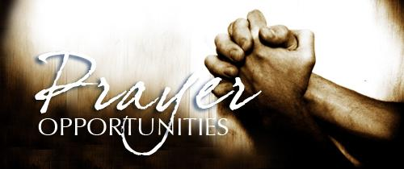

Monday, 6:30PM - Ladies Prayer, Joy Room –
ALL ladies welcome
Tuesday, 6AM – Men’s Prayer, JAM room – ALL men welcome
Wednesday, 9AM – Prayer, Situation Room – For Anyone
JUNE

BIRTHDAYS ANNIVERSARIES
1 Kamdyn Alexander 2, 1973 John & Danella
2 Sam Dirnbeck Dimmick
3 Dennis Bowers
5 Jeydon Fries 13, 1987 Gary & Barbara
7 Connie Howard Jemison
8 Chloe Mize
Zachary Helfrich 18, 1971 Keith & Connie
Julia Foder Howard
12 Marj DeNeal
Tim Ondo 20, 2009 Brian & Honey
13 Emily Britton Bejmovicz
Wendi Wilson
14 Kim Fleck 25, 2011 Andrew &
15 Gary Jemison Taylor Woolard
16 Laura Eader
17 Lily Jenkins
21 Debbie Prince
22 Kaye McClintock
Faye Grzanich
23 Todd Culp
Makayla Dunning
Oliver Bahorich
24 Kenny Jacobs
Isabella Wilson
25 Bill Mabry
Tom Woolard
27 Todd Rice
29 Bridgette Jordan

